## Managing Your Onshape Account

Your Onshape account includes access to Onshape via:

* Browser, via: Chrome, Firefox, and Safari
* Mobile devices, including: iPad, iPad mini, iPod, iPhone, and Android devices

|  |  |
| --- | --- |
| https://cad.onshape.com/help/Content/Resources/Images/icons/preferences_composer_20x20.png | To learn more about mobile devices and operating systems supported, see [Onshape Mobile Devices](https://cad.onshape.com/help/Content/mobiledevices.htm). For more information about Onshape on a mobile device, watch this video: [Mobile Devices Video](https://cad.onshape.com/help/Content/mobile-devices-video.htm). |

Click your name in the upper right corner to access your Onshape account Information.

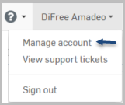

For Free subscription users, the top of the page contains information about metrics. Professional subscription users do not have this banner because there are no limits.



Use Manage account to view and manage your profile and user account, including:

* Profile - Name, username, nickname, biographical information, and company name
* Emails - Email addresses associated with your account
* Preferences - Unit preferences for all documents you create, including for length, angle, and mass
* Security - Reset your password and enable/disable two-factor authentication
* Usage - Number of private documents, private document storage, and total storage
* Devices - The mobile devices authorized to use your account
* Applications - A list of the third-party applications which you have purchased and allowed to access your Onshape account, including the ability to control application access to Onshape documents manually.
* Subscriptions - The details of all Onshape subscriptions for which you are a member, including payment details; you can cancel, upgrade, and change credit card information here
* Payment options - Basic credit card information associated with any account for which you are responsible for payment
* Payment history - A list of all charges made against your account
* Company - This tab appears when you are either the owner of a Company Professional subscription, or have been added to such; also lists the basic company information as well as all users associated with the company
* Teams - Teams you are a member of; ability to create teams (if allowed by your subscription type) and view a list of members

The remainder of this topic explains the tabs on this page:

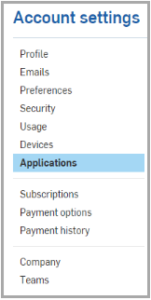

### Profile

Onshape automatically records the first and last names you specify during sign up; here you can also enter an optional company name, and a personal nickname for display in the system (in the upper right-hand corner of the user interface).

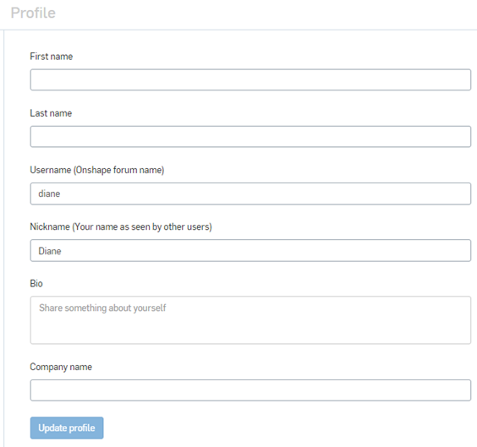

### Emails

You can specify up to three email addresses with which to access your Onshape account. One of the addresses functions as your primary email, used for all Onshape notifications and communications. Change the primary designation at any time after adding at least one more email address to your account.

All email addresses added to the system must be verified. Check the email address for a verification notice from Onshape.

Note that any email addresses associated with an account (even those not designated as primary) cannot be used to create another Onshape account.

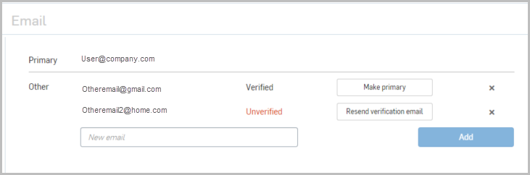

Remove an email from your account by clicking the small "x" next to the email listing (shown above).

You can use any of the verified email addresses on your account to request a reset for a forgotten password.

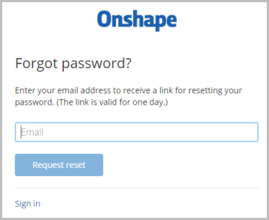

### Preferences

Onshape defaults to inch, degree, pound for units of measure for all documents; this encompasses all measurements in Part Studios and Assemblies, all values displayed in sketch dimensions, and the default input units for all features as well. (These default units do not affect any external files you import.)

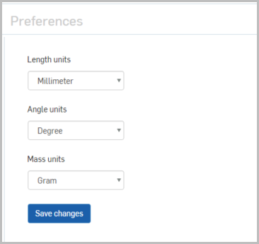

In addition to setting default units for all documents you create (through this Settings tab), you can also change and specify default units for a specific workspace in a document through the [Document toolbar](https://cad.onshape.com/help/Content/toolbars.htm#document_toolbar) in a document.

Despite the default settings, Onshape allows you to specify a different unit of measure in any numeric field; the value is converted to the default unit automatically. For example, if the default unit is inches, you can still specify a different unit type (for example "10mm") in a numeric field.

### Security

Change your Onshape system password, and also enable (or disable) [Two-Factor Authentication](https://cad.onshape.com/help/Content/twofactorauthentication.htm#Two-Fact).

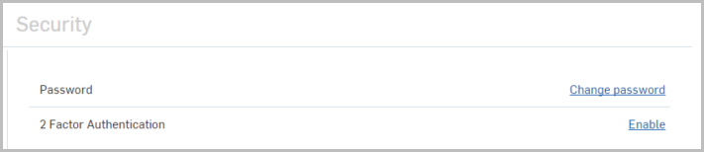

When resetting your password, a list of guidelines appears. Each requirement is checked as your password fulfills the requirement:

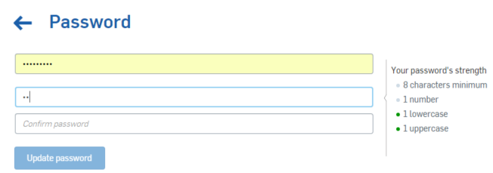

### Usage

This image shows the Usage page for a Professional subscription; a Free subscription user sees slightly different figures as well as a button to Upgrade.

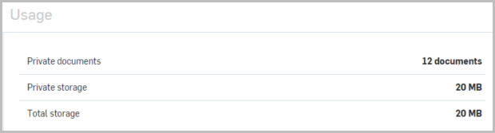

View the usage metrics for your account, including:

* Number of private documents currently created (including those in Trash)
* Amount of private storage space used; storage used for private documents only (including those in Trash)
* Amount of total storage space used; storage used for all documents you own (including those shared with you and those in Trash)

### Devices

A list of all mobile devices associated with and authorized to use this account. Once you access your Onshape account on a mobile device, that mobile device is listed here.

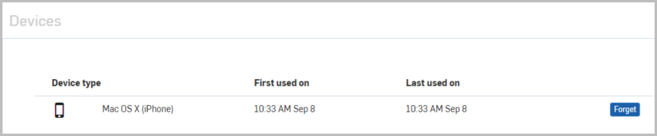

### Applications

Onshape allows you to use partner third-party applications with your Onshape account. To access the Onshape App Store, navigate to [http://appstore.onshape.com](http://appstore.onshape.com/) and sign in with your Onshape account credentials.

Here's a list of frequently asked questions ([App Store FAQs](https://cad.onshape.com/help/Content/app_store_faqs.htm)).

Once signed in to the App store, you can browse the apps available and make purchases.

#### **Types of apps**

Onshape third-party apps are of the following types:

* Integrated Application - Accessible from within an Onshape document
* Connected Desktop Application - Downloaded from the third-party website and installed on your physical machine
* Connected Cloud Application - Accessible from a cloud-based service

#### **Actions on apps**

* Revoke - Remove an app's access to Onshape data. This does not remove the app from Onshape. If you use this app again, you will be prompted to allow access to your Onshape data.
* Authorize Application - Authorize the purchased app to access your Onshape data. You see this option in an Onshape document: Click the https://cad.onshape.com/help/Content/Resources/Images/icons/plussign.png icon > Add Application > application-name. A new tab opens and becomes active in your Onshape document.
* Control application access to my documents individually through the Share dialog? - Some applications prompt you to allow the app access to all your Onshape documents. If you would like to have control on a per document basis, turn this option on.

If you have granted access prior to turning this switch on, that access is still granted. If you turn this switch off, all access previously granted is still granted. When this switch is on, you must use the [Share dialog](https://cad.onshape.com/help/Content/sharedocuments.htm) to allow a specific application access to a specific document.

1. Click https://cad.onshape.com/help/Content/Resources/Images/comments/share.png.

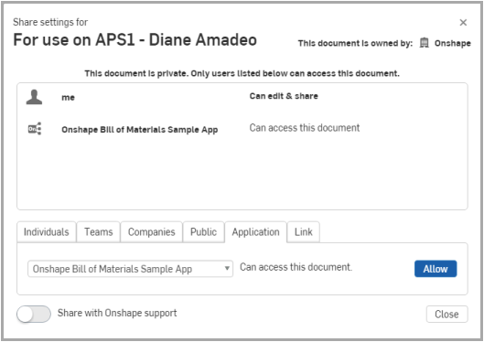

1. On the Application tab, select the application from the drop down and click Allow.
2. To revoke access, click the x next to the application name at the top of the dialog.

Note that purchased apps that are authorized to access your Onshape data are listed in three places in your Onshape documents:

* Applications tab in the user profile (Accounts page) - Shows all apps you have authorized to access your Onshape data.
* Subscriptions tab in the user profile - Shows all apps for which you have a subscription.
* On the Add application from the https://cad.onshape.com/help/Content/Resources/Images/icons/plussign.png menu at the bottom of your Onshape window.

### Subscriptions

View the list of Onshape subscriptions and app subscriptions you have purchased.

Free subscription

Free subscription members may belong to only one Onshape subscription at a time (per email address); to change from a Free subscription to a Professional subscription, click [Upgrade to Professional](https://cad.onshape.com/help/Content/plan-professional-upgrading.htm) at the bottom of the left pane.

OpenProfessional Subscription

A user may belong to one or many Professional subscriptions per email address. Note that you have one set of credentials per email address.

On your account > Subscriptions tab > company page, you can:

* Edit the membership of the company, including [Adding and removing company members](https://cad.onshape.com/help/Content/company.htm#adding_and_removing_users)
* Update your credit card information
* Cancel a subscription that you own; transitioning all users to Free subscriptions immediately (users with other Professional subscriptions are not transitioned to a Free subscription)
* Click View for a printable invoice

For answers to common questions about Onshape's payment processes and plans, see [Subscriptions and Payment FAQs](https://cad.onshape.com/help/Content/plansfaqs.htm#Plans) and[Onshape Subscriptions](https://cad.onshape.com/help/Content/plans-choosing.htm), respectively.

### Payment options

If you are the owner of the account, you can change credit card information, or remove a card from the listing. Note that a credit card may be removed from the account only if it is not associated with a subscription:

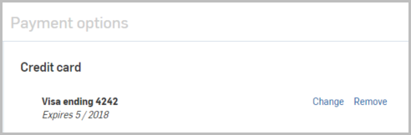

At no time is any credit card information displayed. You may simply enter new credit card information and that will supersede any previously entered information.

### Payment history

This area lists a chronological history of all payments made for the account. Click View to access a print-friendly invoice.

### Company

This area lists all the Companies of which you are either owner or member. Use this page to [manage](https://cad.onshape.com/help/Content/company.htm) your companies.

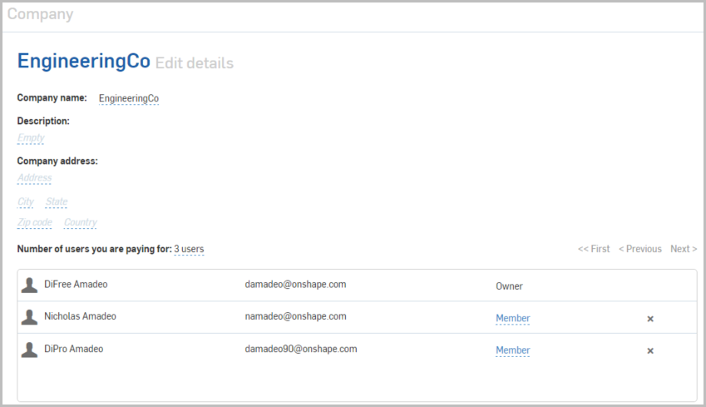

### Teams

All Onshape plans allow you to create Teams of other Onshape users. This is an informal and convenient way to share collectively with a group of Onshape users. There are no document ownership requirements, as with companies, and users can be added or removed at any time by the designated Team Admins. Learn more about [Creating and Managing Teams](https://cad.onshape.com/help/Content/organizations.htm).

